Temporary Accounting Processes Revision
During the COVID-19 Closure
The Bishop’s Office continues to work hard to provide our Episcopal congregations and ministries with support and resources throughout the social and economic disruptions due to COVID-19. Due to Governor Inslee’s order, we are further curtailing our limited operations to protect staff and those we serve from exposure to COVID 19. We hope these steps will keep our organization ready to respond to spiritual needs throughout the closure and beyond.
Check requests
Deposits
Payroll

+++++

Check requests
We work hard to process requests for reimbursement and vendor payments as quickly as possible. Even when fully staffed, we have not guaranteed checks could be processed the same day the request was received.
Submit check requests remotely
Use the PDF check request form to submit check requests remotely
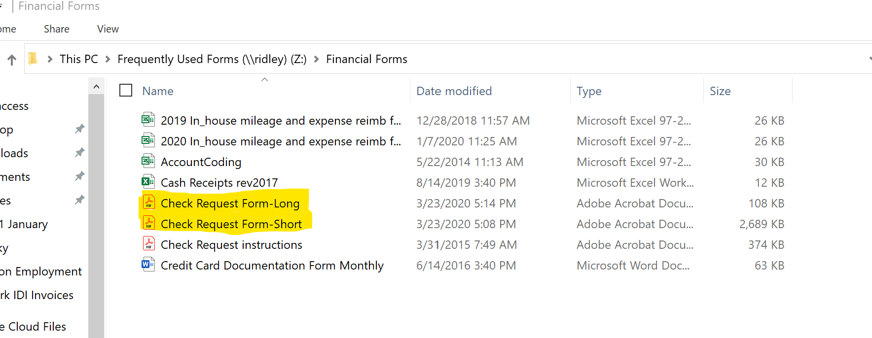
Figure 1: Check Request Location
- Complete the coding sections normally.
- Attach receipts or other supporting documentation electronically: PDF, JPG
  - While we accept electronic images, if the image is not legible to accounting staff, you may be asked to resubmit the image or send it as a hard copy. This will delay the processing of payments.
- Authorizing the request remotely: Our treasurer and accounting departments have ruled that for the duration of the closure, an authorized spender can remotely approve requests via email.
  - If you are authorized to spend a budget line item, you may sign for yourself and confirm the authorization in the text of the email when you send it.
  - If you are not able to authorize your own request, you can
    - Send the request to your supervisor to authorize and forward.
    - Send the request to your supervisor and carbon copy (cc:) accounting. Your supervisor can approve the request by replying to all.
    - Make sure to talk with your supervisor about his/her/their preference on how to manage this so that your reimbursements are not delayed.
- Retain original copies of receipts and supporting documentation for filing once the House reopens. These records help protect you in the case that the IRS audits you and requires proof that the money wasn’t income but reimbursement.

Deposits
We make one weekly deposit; this has not changed. If the Diocese of Olympia receives funds from a third party and then makes then available to you, there may be a processing delay. Depending on when the check or funds were received the delay may be up to 5 business days. If you have questions about when deposited funds have been received or are available, contact the accounting office.

Payroll and Recurring Payments
Diocesan payroll is processed twice monthly for most staff, and once a month for some staff members. Payroll will not be interrupted by the closure.
If you receive regular payments (grants, etc) from the Diocese of Olympia operating fund: those regular payments should not be affected by the closures.

